**Model the current and future risk of locally acquiring Chagas with Habitat Suitability Distribution of Chagas Disease vectors triatomine in North America with presence-only data**

**Introduction**

* The Chagas Disease, traditionally considered as a disease prevalent in Latin America, is estimated to infect approximately 6-7 million people worldwide.1 In the United States, with no large-scale screening of Chagas Disease,7 currently, the best estimation of 288,000 - 347,000 infected patients and 10,000 autochthonous Chagas infection cases7,8 was calculated from outdated survey data. Alternative measures of the current and future risks of locally acquiring the Chagas Disease are required for us to better evaluate the risk.
* The Chagas Disease has two phases, acute and chronic, with symptoms ranging from asymptomatic in the acute phase to cardiac or gastrointestinal disease during the chronic phase.2 The infection persists for a lifetime without effective treatment.2
* Regarding treatment, the decades-old effective drugs benznidazole and nifurtimox produce side effects which causes one in five patients to abandon treatment,3 while vaccines are still in development4.5
* Early diagnosis during asymptomatic period is essential for effective treatments and potentially prevent congenital transmission and entering chronic phase. However, no large-scale screening exists in the United States for detecting infections during this critical period.7 As of December 2017, Chagas Disease has only been reported in six states: Texas, Arizona, Arkansas, Tennessee, Mississippi, Louisiana, with most cases identified by blood centers.3,7,31
* The Chagas disease is caused by the pathogen *Trypanosoma cruzi*, which is majorly transmitted by the infectious waste of triatomines contacting with human’s membrane or wound, or food contaminated by the infectious waste been consumed by human.1 Chagas can also be transmitted through contaminated blood transfusion and organ transplantations, congenital, ingestion of contaminated food, and postnatal infections. Other than humans, animals can also be infected. For example, raccoons, woodrats, opossums, non-human primates, red pandas and red-necked wallabies have all been found infected with *T. cruzi* in United States.6, 40, 41
* The study conducted in 2024 revealed that the pathogen T. cruzi has been found to appear in 18 US states, mostly in Texas, Louisiana and New Mexico34.
* Under climate change, the habitat of the triatomines might extend into traditionally unoccupied regions in North America, increasing the risk of unprepared populations locally acquiring Chagas, while only a few studies have been done in this area.3,39
* The lack of large-scale serological screening and monitoring of other Chagas transmission paths hinders us from getting more accurate estimation of current burden. Efforts has been put into research, including the newly formed RAISE project, The buRden of ChAgas dISEase in the contemporary world’37.
* This study seeks to provide an alternative measure by studying the Habitat Suitability Distribution (HSD) of the Chagas Disease vector triatomines. In all the triatomine species observed in North America, we selected and modeled 14 species from our database. All these species except *P. hirsuta* have been reported to carry *T. cruzi* and transmitted Chagas (see details in Appendix 1)10,11,12,13,14,15,33.
* We created a most complete database for triatomines in North America (referring to United States, Mexico and Canada in this study) and conduct HSD modeling for both historical (1991-2020) and CMIP6 future projected (2071-2100) scenarios with two machine learning models: MaxEnt and downsample Random Forest, which have good performance for modeling species distribution with sparse presence-only data. The triatomine database and HDS maps are presented to support healthcare providers and public health researchers in their decision making.

**Material and Method**

Study Design

We first constructed a North America triatomine database, including observation data till July 2023. For each species, we use observation data points from this dataset combining with pseudo-absence data points to sample historical environmental predictors and train MaxEnt and downsample Random Forest. The environmental predictors include bioclimatic and land cover data for historical period (1991-2020) and 2071-2100 under 4 CMIP6 scenarios: SSP1 RCP2.6, SSP2 RCP4.5, SSP3 RCP7.0 and SSP 5 RCP8.5 (CO2 emission increases as we go along these 4 scenarios). Then, the two models produce HSD maps for historical and 2071-2100 CMIP6 scenarios with these environmental predictors. We analyzed the model evaluation metrics and the differences of the HSD maps. Figure 1 is a flowchart presenting the modeling process.

Triatomine Database

We compiled the North America Triatominae Database by combing multiple published datasets: ‘New American dataset’ (19,600 records),16 the Disease Vector Database from Moffett et al. (567 records),17 Texas triatomine database 2012-2015 (382 records),18 North Mexico Triatominae dataset (388 records),19 and iNaturalist research-standard citizen science observations (2901 records).20,21  Additionally, we incorporated an unpublished dataset from Alejandro Martínez-Ibarra (220 records) and 875 newly gathered records of triatomine observations published in January 2022 to July 2023. These recent records were collected by our team from databases Semantic Scholar, Science Direct and DataTri.

The raw data of all species was cleaned and filtered before feeding into models. The cleaning process removed points which are duplicated, wrongly/incompletely georeferenced, or not having a clear capture time are removed (scripts available in Appendix 1). The filtering process removed points which are closer than 5 km with the R spThin library. The North America Triatominae Database and filtered datasets are available on Texas Data Repository22.

Environmental Predictors

The 39 environmental predictors (Table 1) consists of bioclimatic and land cover variables, the bioclimatic variables are from the AdaptWest bioclimatic dataset,23,2425 and the land cover variables are from the Global 7-land-types LULC projection dataset under SSPs- RCPs dataset,26.27 Both datasets are of 1-km resolution and have historical and future projected data under 4 CMIP6 scenarios. For the land cover historical predictor, we use their 2015 land cover data for historical period since the average land cover for 1991-2020 has not been found and most of our triatomine observations were between 2010-2020.

Machine Learning Models

We used the MaxEnt from R dismo package and downsample RF from randomForest R package to train and predict habitat suitability. These two have been found to be top performance models for presence-only modeling in a previous study.28 Models were trained with pseudo-absence data selecting randomly outside a 5-km buffer and no environmental predictor preprocessing (eliminate correlated variables and perform PCA). For each species, we trained MaxEnt and downsample RF with actual observation points and 10,000 pseudo-absence points. Different from traditional RF, down-sample RF randomly selects the pseudo-absence points to match the number of observation points at tree level. Aligning with Valavi, Roozbeh, et al.,28 we implemented MaxEnt with dismo::maxent (needs maxent.jar) R package, and downsample RF using the randomForest R package by modifying code from Valavi, Roozbeh, et al.30

**Results**

Database

We created a database for all the triatomine observation data, which is publicly available at Texas Data Repository. The raw dataset contains 24,933 observations. The cleaned Americas dataset for the Americas contains 20,277 observations and cleaned North America contains 12,578 observations. From all the species with observations in the cleaned North America dataset, we further cleaned them to remove observation points that are closer than 5 km with spThin R package (Figure 2), and selected the 14 species with more than 39 records (the number of environmental predictors). We proceed to HSD modeling with these 14 species: *T. sanguisuga*, *T. dimidiata*, *T. gerstaeckeri*, *T. protracta*, *T. longipennis*, *T. rubida*, *M. pallidipennis*, *T. barberi*, *T. mexicana*, *P. lecticularia*, *T. recurva*, *T. mazzottii*, *P. hirsute* and *T. indictiva*.

Model Performance

The performance of MaxEnt and RF tends to agree on their AUC and TSS scores as the number of training samples increases, while this trend is not observed in MAE and Bias (Figure 3).

It is agreed by 5 variable importance measurements of MaxEnt and RF that, DD18 (Degree-days above 18 °C) is the most important variables for *T. sanguisuga*; for *T. dimidiata* it is TD (Difference between MCMT (Mean temperature of the coldest month) and MWMT (Mean temperature of the warmest month), as a measure of continentality), for *T. gerstaeckeri* it is PAS (Precipitation as snow), and for *T. protracta* it is CMD (Hargreave’s climatic moisture index). The importance measurement spider charts for all 14 species can be found in Appendix 1.

Habitat Suitability Distribution

The HSDs for the four species having the most observation points are shown below, and the HSDs for the other 10 species can be found in Appendix 1. In historical HSD maps, predictions from both models cover regions located by observation points, with RF giving a higher suitability values for those regions. For 2071-2100 predictions, HSDs tend to spread out more in higher emission scenarios for both models (Figure 4, for the four species with the most observation points after filtering), with predictions from RF generally more aggressive, consistently displaying a higher suitability value and broader spatial coverage. Among all, *T. sanguisuga, T. protracta, P. lecticularia, P. hirsute* and *T. indictiva* have the most significant suitable habitat expansion to the north in 2071-2100. (widest distribution currently)

**Discussion**

* We created the most complete open-sourced North America triatomine database combining well-established databases, newly published datasets, and citizen science dataset. The cleaned data could be used for conducting further triatomine ecological niches studies on regional scale, and the filtered version could be directly used for model development.
* MaxEnt and downsample RF both have good agreements on evaluation metric results for most of the nine species with training samples no fewer than 143; therefore, we would regard habitat suitability maps for these nine species as reliable: *T. sanguisuga*, *T. dimidiata*, *T. gerstaeckeri*, *T. protracta*, *T. longipennis*, *T. rubida*, *M. pallidipennis*, *T. barberi*, *T. mexicana.*
* We applied a new way to evaluate differences between prediction maps on regional scale, for which we calculated the percentage difference of pixel-wise summation of two prediction raster maps. This percentage differences converges to a low value at the right end where models have more training samples (Figure 5).
* RF models have a consistent negative Bias score (Figure 3), which indicates they could be used as an upper bound. At the same time, the observation points are well covered by high suitability regions predicted by RF, while the ‘outlier’ points are sometimes missed by those from MaxEnt models (Figure 4 and Appendix 1).
* The expanding suitable habitat for triatomines signals a growing risk of locally acquired Chagas diseases. Given an increasing locally acquiring risk, integrating habitat suitability modeling with screening and public education programs will be essential for preparing at-risk populations for the challenges ahead.
* For blood donation testing, since unfortunately no single serological test has both high sensitivity and high specificity, WHO advices the use of one high sensitivity test plus one high specificity test to identify Chagas disease.
* In United States, Starting from December 2017, FDA requires blood centers to use a licensed screening test for antibodies of *T.cruzi.* (<https://www.fda.gov/media/101270/download>)
* Canadian blood services only conduct tests for donors who were born or lived, or whose mother or maternal grandmother was born or lived in countries where Chagas disease occurs, as well as donors with a travel risk. (<https://www.blood.ca/en/about-us/media/chagas-disease/faqs-chagas-disease#:~:text=Do%20you%20test%20donated%20blood,also%20be%20tested%20for%20Chagas>. ) With habitat of triatomines expanding to Canada at the end of this century, Canada has a potential growing risk of Chagas Disease, which also agreed with experts opinion on ranking Chagas as one of the top three infectious disease to concern under climate change38.
* For Mexico, it is estimated that between 1.1 to 4 million people are infected with *T. cruzi*, and federal regulations (NOM-253-SSA1-2012) requires all blood donors to be tested for T. cruzi (<https://www.gob.mx/cms/uploads/attachment/file/219069/NOM-253-SSA1-2012_Para_la_disposicion_de_sangre_humana_y_sus_componentes_con_fines_terapeuticos.pdf>), while due to limited budget, most blood centers can only afford conducting one test on blood donations35.
* suggestion: potentially make Chagas disease notifiable at national level)(<https://ndc.services.cdc.gov/search-results-year/>)
* The presence of triatomines is not associated with poor housing, but you find them in garages, California case in the bedroom36.
* Suggestions: (clinician training in US)(US, Mexico cooperation along the boarder)
* CDC doesn’t consider Chagas to be endemic in United States, for the reason that they believe the risk of locally acquiring Chagas is low3, but our study shows that the locally acquiring risk is high, which leading to Chagas is potentially endemic but under-reported in United States.

**Tables**

Table 1 (edited)

|  |  |
| --- | --- |
| Species | Number of Observations in Cleaned North America Dataset |
| *Triatoma gerstaeckeri* | 4464 |
| *Triatoma sanguisuga* | 2217 |
| *Triatoma dimidiata* | 1679 |
| *Triatoma protracta* | 864 |
| *Triatoma rubida* | 492 |
| *Triatoma longipennis* | 482 |
| *Meccus pallidipennis* | 465 |
| *Triatoma barberi* | 380 |
| *Triatoma mexicana* | 358 |
| *Paratriatoma lecticularia* | 275 |
| *Triatoma indictiva* | 204 |
| *Triatoma mazzottii* | 158 |
| *Triatoma recurva* | 112 |
| *Dipetalogaster maxima* | 96 |
| *Triatoma phyllosoma* | 71 |
| *Paratriatoma hirsuta* | 64 |

**Figures**

Figure 1

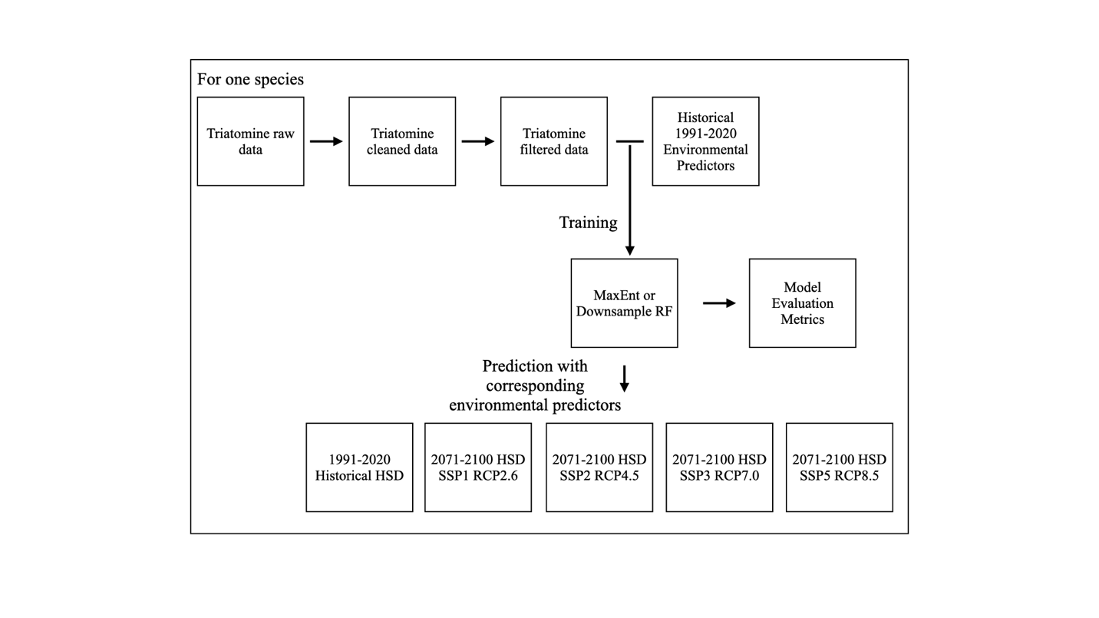

Figure 2: The geospatial distribution of filtered observation points for the 16 species: A) *T. sanguisuga*, B) *T. dimidiata*, C) *T. gerstaeckeri*, D) *T. protracta*, E) *T. longipennis*, F) *T. rubida*, G) *M. pallidipennis*, H) *T. barberi*, I) *T. mexicana*, J) *P. lecticularia*, K) *T. recurva*, L) *T. mazzottii*, M) *P. hirsuta*, N) *T. indictiva*, O), *D. maxima* P) *T. phyllosoma*. The number of filtered observation points (red) and the number of cleaned observation points (black) are noted at the bottom right of each subplot. The subplots are arranged in the ascending order of the number of filtered observation points.

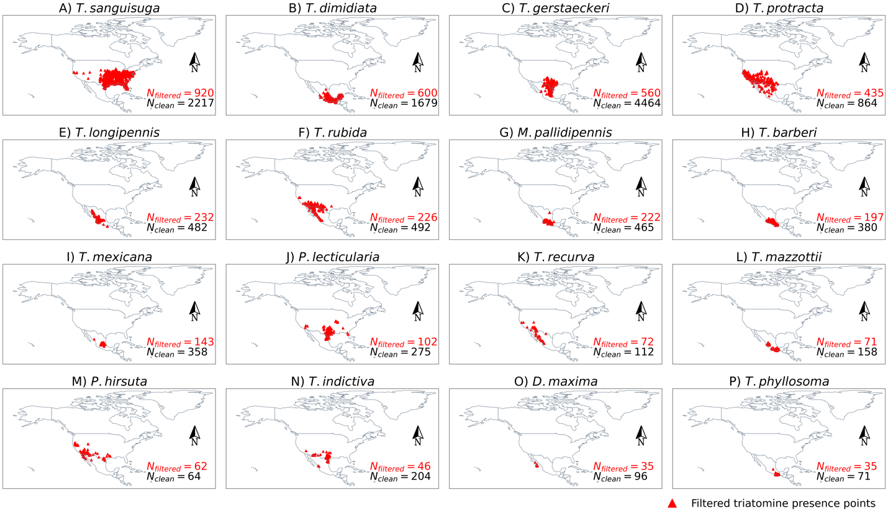

Figure 3

Figure 4a

Figure 4b

Figure 4c

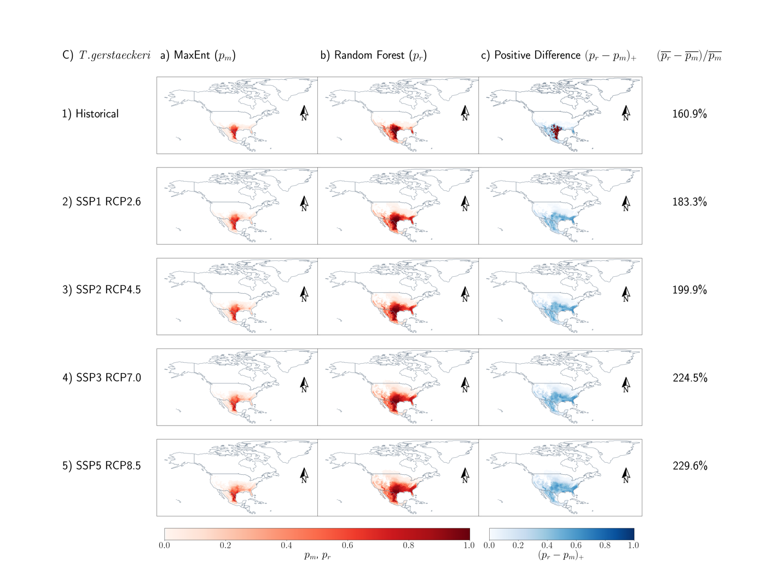

Figure 4d

Figure 5

**References**

1. WHO W. Chagas disease (American trypanosomiasis). Epidemiology. 2020:Date ac- cessed: July 16, 2024.
2. Bern C, Messenger LA, Whitman JD, Maguire JH. Chagas disease in the United States: a public health approach. Clinical microbiology reviews. 2019;33(1):10–1128.
3. Higuita NIA, Beatty NL, Forsyth C, et al. Chagas disease in the United States: a call for increased investment and collaborative research. The Lancet Regional Health–Americas. 2024;34.
4. Dumonteil E, Herrera C, Marx PA. Safety and preservation of cardiac function follow- ing therapeutic vaccination against Trypanosoma cruzi in rhesus macaques. Journal of Microbiology, Immunology and Infection. 2023;56(2):400–407.
5. Jones KM, Poveda C, Versteeg L, Bottazzi ME, Hotez PJ. Preclinical advances and the immunophysiology of a new therapeutic Chagas disease vaccine. Expert Review of Vaccines. 2022;21(9):1185–1203.
6. Hodo CL, Wilkerson GK, Birkner EC, Gray SB, Hamer SA. Trypanosoma cruzi transmission among captive nonhuman primates, wildlife, and vectors. EcoHealth. 2018;15:426– 436.
7. Irish A, Whitman JD, Clark EH, Marcus R, Bern C. Updated estimates and mapping for prevalence of Chagas disease among adults, United States. Emerging infectious diseases. 2022;28(7):1313.
8. Manne-Goehler J, Umeh CA, Montgomery SP, Wirtz VJ. Estimating the burden of Cha- gas disease in the United States. PLoS neglected tropical diseases. 2016;10(11):e0005033.
9. Cantey PT, Stramer SL, Townsend RL, et al. The United States Trypanosoma cruzi In- fection Study: evidence for vector-borne transmission of the parasite that causes Chagas disease among United States blood donors. Transfusion. 2012;52(9):1922–1930.
10. Bern C, Kjos S, Yabsley MJ, Montgomery SP. Trypanosoma cruzi and Chagas’ disease in the United States. Clinical microbiology reviews. 2011;24(4):655–681.
11. Waleckx E, Suarez J, Richards B, Dorn PL. Triatoma sanguisuga blood meals and poten- tial for Chagas disease, Louisiana, USA. Emerging infectious diseases. 2014;20(12):2141.
12. Reisenman CE, Lawrence G, Guerenstein PG, Gregory T, Dotson E, Hildebrand JG. Infection of kissing bugs with Trypanosoma cruzi, Tucson, Arizona, USA. Emerging infectious diseases. 2010;16(3):400.
13. Salazar Schettino PM, Rosales Pin ̃a JS, Rojas Wastavino G, Cabrera Bravo M, Vences Blanco M, Lo ́pez Ca ́rdenas J. Triatoma mexicana (Hemiptera: Reduviidae) in Guanajuato, Mexico: house infestation and seasonal variation. Memorias do Instituto Oswaldo Cruz. 2007;102:803–807.
14. Ramsey J, Ordon ̃ez R, Cruz-Celis A, et al. Distribution of domestic Triatominae and stratification of Chagas disease transmission in Oaxaca, Mexico. Medical and Veterinary Entomology. 2000;14(1):19–30.
15. Magall ́on Gast ́elum E, Magdaleno Pen ̃aloza NC, Katthain Duchateau G, Trujillo Con- treras F, Lozano Kasten FJ, Hern ́andez Guti ́errez RJ. Distribucio ́n de los vectores de la enfermedad de Chagas (Hemiptera: Reduviidae: Triatominae), en el estado de Jalisco, M ́exico.. Centro de Investigaciones Regionales” Dr. Hideyo Noguchi”. Universidad .... 1998.
16. Ceccarelli S, Balsalobre A, Cano ME, et al. Datos de ocurrencia de triatominos amer- icanos del Laboratorio de Triatominos del CEPAVE (CONICET-UNLP). Version 1.6. Centro de Estudios Parasitol ́ogicos y de Vectores (CEPAVE).. 2022.
17. Moffett A, Strutz S, Guda N, et al. A global public database of disease vector and reservoir distributions. PLoS Neglected Tropical Diseases. 2009;3(3):e378.
18. Arroyo TF. Texas 2012-2015. 2024.
19. Rebollar-T ́ellez EA. Triatomine North Mexico Dataset. 2024.
20. GBIF.Org User . Occurrence Download. 2023.
21. contributors . iNaturalist Research-grade Observations. 2022.
22. Huang L, Sa ́nchez A, Rebollar-T ́ellez EA, et al. Triatomine Database North and South Americas 2023 version. 2024.
23. Project A. Gridded current and projected climate data for North America at 1km reso- lution, generated using the ClimateNA v7.30 software (T. Wang et al., 2022). 2022.
24. Wang T, Hamann A, Spittlehouse D, Carroll C. Locally downscaled and spatially cus- tomizable climate data for historical and future periods for North America. PloS one. 2016;11(6):e0156720.
25. Mahony CR, Wang T, Hamann A, Cannon AJ. A global climate model ensemble for downscaled monthly climate normals over North America. International Journal of Cli- matology. 2022;42(11):5871–5891.
26. Chen G, Li X, Liu X. Global land projection based on plant functional types with a 1-km resolution under socio-climatic scenarios. Scientific Data. 2022;9(1):125.
27. Chen G, Li X, Liu X. Future global land datasets with a 1-km resolution based on the SSP-RCP scenarios. Zenodo. 2021.
28. Valavi R, Guillera-Arroita G, Lahoz-Monfort JJ, Elith J. Predictive performance of presence-only species distribution models: a benchmark study with reproducible code. Ecological monographs. 2022;92(1):e01486.
29. Konowalik K, Nosol A. Evaluation metrics and validation of presence-only species dis- tribution models based on distributional maps with varying coverage. Scientific Reports. 2021;11(1):1482.
30. Valavi R, Elith J, Lahoz-Monfort JJ, Guillera-Arroita G. Modelling species presence-only data with random forests. Ecography. 2021;44(12):1731–1742.
31. Bennett C. Chagas disease surveillance activities—seven states, 2017. MMWR. Morbidity and Mortality Weekly Report. 2018;67.
32. Bennett C, Straily A, Haselow D, et al. Chagas Disease Surveillance Activities — Seven States, 2017. MMWR Morb Mortal Wkly Rep 2018;67:738–741. DOI: <http://dx.doi.org/10.15585/mmwr.mm6726a2>.
33. Carlos Alberto Flores-López, Lynneth Rivas-García, Guillermo Romero-Figueroa, Aldo Guevara-Carrizales, Haran Peiro-Nuño, Teresa López-Ordoñez, Rafael Bello-Bedoy, Infection Rate of Trypanosoma cruzi (Trypanosomatida: Trypanosomatidae) in Dipetalogaster maxima (Hemiptera: Reduviidae), Journal of Medical Entomology, Volume 59, Issue 1, January 2022, Pages 394–399, <https://doi.org/10.1093/jme/tjab147>
34. Llovera, Arnau, et al. "Genetic Diversity of Trypanosoma cruzi in the United States of America: The Least Endemic Country for Chagas Disease." *Life* 14.7 (2024): 901.
35. González-Guzmán, Saúl, et al. "Seroprevalence of Trypanosoma cruzi in Eight Blood Banks in Mexico." *Archives of Medical Research* 53.6 (2022): 625-633.
36. Bear-Johnson, Mir, and Mustapha Debboun. "Triatoma protracta (Uhler, 1894)(Hemiptera, Reduviidae) with Trypanosoma cruzi (Chagas, 1909)(Kinetoplastida, Trypanosomatidae) in the Central Valley of California, USA." *Journal of Vector Ecology* 47.1 (2022): 138-140.
37. Ribeiro, Antonio Luiz Pinho, et al. "The burden of Chagas disease in the contemporary world: the RAISE study." *Global Heart* 19.1 (2024).
38. Cox, Ruth, Javier Sanchez, and Crawford W. Revie. "Multi-criteria decision analysis tools for prioritising emerging or re-emerging infectious diseases associated with climate change in Canada." *PloS one* 8.8 (2013): e68338.
39. Forsyth, Colin, et al. "Climate change and Trypanosoma cruzi transmission in North and central America." *The Lancet Microbe* 5.10 (2024).
40. Busselman, Rachel E., and Sarah A. Hamer. "Chagas disease ecology in the United States: recent advances in understanding Trypanosoma cruzi transmission among triatomines, wildlife, and domestic animals and a quantitative synthesis of vector–host interactions." *Annual review of animal biosciences* 10.1 (2022): 325-348.
41. Hodo, Carolyn L., and Sarah A. Hamer. "Toward an ecological framework for assessing reservoirs of vector-borne pathogens: wildlife reservoirs of Trypanosoma cruzi across the southern United States." *ILAR journal* 58.3 (2017): 379-392.